

ASSET VERIFICATION AND RECORDING TOOL KIT


Plot 31, Bukoto Street
P.O Box 7657, Kampala, Uganda
+256 (0) 39 2000216/0772525235
email: cpa@cpa.ug

www.cpa.com

August to September 2026

VERIFICATION DETAILS

NAME OF THE REGION: | NOTHERN REGION
SUB-REGION: | LANGO-SUB REGION
Name of Local Government | DOKOLO DISTRICT LOCAL GOVERNMENT
VERIFIER PARTICULARS
Full name | AGANYO MERCY
Contact/ email and Telephone | 0786551826  mercyaganyo22@gmail.com
Supervisor/ Sub team leader
Name | MR.DENIS
Contact | 0779622063
Date of submission | 31ST AUGUST 2026

HEALTH CENTRES
INFORMANT INTERVIEW/DISCUSSION GUIDE (INCHARGE OR RESPONSIBLE PERSON)

Name of Health Centre: ADAGMON HEALTH CENTER III

1a | Does the Facility have a record of all assets provided under UgIFT.  (Obtain a record and verify if it has the costs and numbers supplied | YES
1b | If Not ask how many were supplied and when.

2 | How does this facility Maintain (repair/service/replace) the assets provided under Ugift

Adagmon Health center III uses the Primary Health Care fund to service and repair the damaged equipment.

3 | Does the facility take regular record about functionality/ or breakdown of the assets provided?

Yes, the facility always takes regular records of the equipment to ensure that they are in a good condition and take record of t5hosev that need servicing,

4 | How has the UgIFT support helped in service delivery in the area, any issues, challenges and any recommendations for better program implementation.

The UGIFT support has helped in improving the health of the locals in the community for instance the number of patient admissions in the wards increased because of the mattresses provided and more services can be accessed by the locals.

Challenges: Some departments are not complete for example t5he staff quarters.
The toilet system is not complete and it is non-functional.
The solar system is very weak and therefore it can’t run trans night.

Recommendations: Ugift should assist with the construction of staff quarters.

There is need for a strong solar system that can run all the equipment trans night.

PROCEED TO VERIFICATION AFTER THIS DISCUSSION

Health Centre checklist

NAME OF LG: DOKOLO DISTRICT LOCAL GOVERNMENT NAME OF HEALTH FACILITY: ADAGMON HEALTH CENTER III

Equipment/ Item | Department | Asset Number | Item  Description | Life in Months | Tag Number ( engrave no.) | Date Of Purchase | Date Placed In Service |  | Recoverable cost | Cost | Acc Dep Cost | Net Book Value | Ytd Deprn | Equipment status | Remarks
B.P. Machine, Digital (2) | OPD |  | Digital | 60 | Not engraved | June 2022 | November 2025 |  |  |  |  |  |  | Functional | Good condition
B.P. Machine (Aneroid wall mounted)(2) | OPD  MCH |  | Manual | 60 | Not engraved | June 2022 | November 2022 |  |  |  |  |  |  | Functional | Good condition
Autoclave 20 Liters.,Duo Operated (1) | MCH |  | Plastic | 60 |  | June 2022 | November 2022 |  |  |  |  |  |  | Functional | Good condition
Bowl, Kick (2) | MCH  IPD |  | Metallic | 70 | Not engraved | June 2022 | November 2022 |  |  |  |  |  |  | Functional | Good condition
Bowl Stand | - | - | - | - | - | - | - |  | - | - | - | - | - | - | -
Counting chamber Neubauer- Improved (1) | MCH |  | Plastic | 24 | Not engraved | June 2022 | November 2022 |  |  |  |  |  |  | Functional | Good working condition
Cupboard Steel, Lockable (6) | OPD MCH  IPD |  | Metallic | 90 | Not engraved | June 2022 | November 2022 |  |  |  |  |  |  | Functional | Good working condition
Drip Stand (8) | IPD  MCH |  | Metallic | 60 | Not engraved | June 2022 | November 2022 |  |  |  |  |  |  | Functional | Good working condition
ESR Stand | - | - | - | - | - | - | - |  | - | - | - | - | - | - | -
Examination Couch (4) | IPD  MCH |  | Metallic with mattress | 90 | Not engraved | June 2022 | November 2022 |  |  |  |  |  |  | Functional | Good condition
Examination light,LED (3) | IPD  MCH  OPD |  | Metallic and plastic | 60 | Not engraved | June 2022 | November 2022 |  |  |  |  |  |  | Functional | Good condition
Glucometer (2) | LAB |  | Digital and plastic | 60 | Not engraved | June 2022 | November 2022 |  |  |  |  |  |  | Functional | Good working condition.
Haemoglobin Meter, Digital | - | - | - | - | - | - | - |  | - | - | - | - | - | - | -
Height Meter (2) | OPD  ANC |  | Metallic | 60 | Not engraved | June 2022 | November 2022 |  |  |  |  |  |  | Functional | Good condition.
Instrument Trolley (3) | MCH  IPD |  | Metallic | 60 | Not engraved | June 2022 | November 2022 |  |  |  |  |  |  | Functional | Good condition
Microscope Binocular (2|) | LAB |  | Metallic | 60 | Not engraved | June 2022 | November 2022 |  |  |  |  |  |  | Functional | Good condition
Otoscope (3) | OPD |  | Manual | 70 | Not engraved | June 2022 | November 2022 |  |  |  |  |  |  | Functional | Good working condition
Patient Screen (6) | IPD  MCH |  | Plastic and digital | 48 | Not engraved | June 2022 | November 2022 |  |  |  |  |  |  | Functional | Good condition.
Patient Trolley (3) | IPD  MCH |  | Metallic | 60 | Not engraved | June 2022 | November 2022 |  |  |  |  |  |  | Functional | Good condition
Refrigerator, Basic (1) | LAB |  | Metallic | 90 | Not engraved | June 2022 | November 2022 |  |  |  |  |  |  | Functional | Good working condition
Stethoscope (3) | OPD  MCH |  | Metallic | 60 | Not engraved | June 2022 | November 2022 |  |  |  |  |  |  | Functional | Good condition
Stop Watch | - | - | - | - | - | - | - |  | - | - | - | - | - | - | -
Stretcher (1|) | IPD |  | Metallic with leather | 60 | Not engraved | June 2022 | November 2022 |  |  |  |  |  |  | Functional | Good working condition
Stove, Gas (1) | MCH |  | Metallic | 60 |  | June 2022 | November 2022 |  |  |  |  |  |  | Functional | Good condition
Weighing Scale with Height Meter, Adult | - | - | - | - | - | - | - |  | - | - | - | - | - | - | -
Weighing Scale, Infant (1) | EPI |  | Plastic | 60 | Not engraved | June 2022 | November 2022 |  |  |  |  |  |  | Functional | Good condition
Weighing Scale, Toddler (1) | MCH |  | Plastic | 90 | Not engraved | June 2022 | November 2022 |  |  |  |  |  |  | Functional | Good condition.
Wheel Chair (3) | IPD |  | Metallic with leather | 36 | Not engraved | June 2022 | November 2022 |  |  |  |  |  |  | Functional | Good working condition
Audio Visual Equipment | - | - | - | - | - | - | - |  | - | - | - | - | - | - | -
Medical Waste Bin (15) | IPD  MCH  LAB  ANC |  | Both Metallic and plastic | 60 | Not engraved | June 2022 | November 2022 |  |  |  |  |  |  | Functional | Good working condition
Wall Clock (1) | MCH |  | Plastic | 12 | Not engraved | June 2022 | November 2022 |  |  |  |  |  |  | Functional | Good condition
Diagnostic Equipment Set for MCH (2) | MCH |  | Stainless steel | 36 | Not engraved | June 2022 | November 2022 |  |  |  |  |  |  | Functional | Good condition
Diagnostic Equipment Set for OPD | - | - | - | - | - | - | - |  | - | - | - | - | - | - | -
Glassware Set, Laboratory, Basic | - | - | - | - | - | - | - |  | - | - | - | - | - | - | -
Hollow Ware Set, Treatment | - | - | - | - | - | - | - |  | - | - | - | - | - | --
 | -
Instrument Set, Dressing (2) | MCH |  | Metallic | 60 | Not engraved | June 2022 | November 2022 |  |  |  |  |  |  | Functional | Good working condition
Instrument Set, Basic ENT | - | - | - | - | - | - | - |  | - | - | - | - | - | - | -
Instrument Set, Suture (2) | Store |  | Metallic | 60 | Not engraved | June 2022 | November 2022 |  |  |  |  |  |  | Non-functional | Still kept in the store because others are in use
Pulse Oximeter, Hand held (2) | IPD |  | Plastic | 70 | Not engraved | June 2022 | November 2022 |  |  |  |  |  |  | Functional | Good working condition
Bed, Adult Patient with Mattress (31) | IPD  MCH |  | Metallic with mattress | 90 | Not engraved | June 2022 | November 2022 |  |  |  |  |  |  | Functional | Good working condition
Bed, Pediatric Patient, With Mattress | - | - | - | - | - | - | - |  | - | - | - | - | - | - | -
Bedside Locker (9) | MCH  IPD |  | Metallic | 120 | Not engraved | June 2022 | November 2022 |  |  |  |  |  |  | Functional | Good working condition
Cupboard, Instrument | - | - | - | - | - | - | - |  | - | - | - | - | - | - | -
Delivery Bed, Hydraulic Manual (1) | MCH |  | Manual | 90 | Not engraved | June 2022 | November 2022 |  |  |  |  |  |  | Functional | Good working condition
Oxygen Therapy Apparatus, Mininum 45L cylinder (1) | MCH |  | Metallic | 90 | Not engraved | June 2022 | November 2022 |  |  |  |  |  |  | Functional | Good condition
Resuscitator Manual, Infant, with all Mask sizes (2) | MCH |  | Plastic | 60 | Not engraved | June 2022 | November 2022 |  |  |  |  |  |  | Functional | Good working condition.
Resuscitator Manual, Adult, with all mask sizes | - | - | - | - | - | - | - |  | - | - | - | - | - | - | -
Suction Apparatus, (Electric) (1) | MCH |  | Electrical | 60 | Not engraved | June 2022 | November 2022 |  |  |  |  |  |  | Functional | Good working condition
Nebulizer, Ultrasonic | - | - | - | - | - | - | - |  | - | - | - | - | - | - | -
Oxygen Concentrator, Duo Flow (1) | Store |  | Electrical | 60 | Not engraved | June 2022 | - |  |  |  |  |  |  | Non-functional | Still in the store because there is no power
Bench (16) | OPD  MCH |  | Wooden with metallic stands | 70 | Not engraved | June 2022 | November 2022 |  |  |  |  |  |  | Functional | Good working condition
Disinfection Buckets (3) | MCH  LAB  OPD |  | Plastic | 60 | Not engraved | June 2022 | November 2022 |  |  |  |  |  |  | Functional | Good condition
Baby Cot | - | - | - | - | - | - | - |  | - | - | - | - | - | - | -
Diagnostic Equipment Set for Ward (2) | MCH |  | Metallic | 60 | Not engraved | June 2022 | November 2022 |  |  |  |  |  |  | Functional | Good working condition.
Hollow Ware Set, Ward | - | - | - | - | - | - | - |  | - | - | - | - | - | - | -
Instrument Set, Delivery (5) | MCH |  | Metallic | 72 | Not engraved | June 2022 | November 2022 |  |  |  |  |  |  | Functional | Good working condition
Instrument Set, Stitch Removing (4) | MCH |  | Metallic | 72 | Not engraved | June 2022 | November 2022 |  |  |  |  |  |  | Functional | Good wo0rking condition
MVA Kit (5) | MCH |  | Plastic | 36 | Not engraved | June 2022 | November 2022 |  |  |  |  |  |  | Functional | Good working condition
Stool, Laboratory (1) | LAB |  | Metallic with leather | 60 | Not engraved | June 2022 | November 2022 |  |  |  |  |  |  | Functional | Good working condition
Penguin Sucker (1) | MCH |  | Plastic | 24 | Not engraved | June 2022 | November 2022 |  |  |  |  |  |  | Functional | Good working condition
Fetoscope, Dopplar (2) | MCH |  | Metallic | 60 | Not engraved | June 2022 | November 2022 |  |  |  |  |  |  | Functional | Good condition
Bubble CPAP | - | - | - | - | - | - | - |  | - | - | - | - | - | - | -
-
Centrifuge (Electric) (1) | LAB |  | Electrical | 72 | Not engraved | June 2022 | November 2022 |  |  |  |  |  |  | Functional | Good working condition
Kangaroo Mother Care Chair (1) | MCH |  | Metallic with leather | 60 | Not engraved | June 2022 | November 2022 |  |  |  |  |  |  | Functional | Good condition
Radiant Infant Warmer | - | - | - | - | - | - | - |  | - | - | - | - | - | - | -
Haemoglobin Meter, Sahli (2) | LAB |  | Manual | 50 | Not engraved | June 2022 | November 2022 |  |  |  |  |  |  | Functional | Good condition
Delivery Bed | - | - | - | - | - | - | - |  | - | - | - | - | - | - | -
Examination light | - | - | - | - | - | - | - |  | - | - | - | - | - | - | -
-
Instrument set, ENT Basic for HCIII | - | - | - | - | - | - | - |  | - | - | - | - | - | - | -
Bag Valve mask (Ambu Bag), Neonatal (1) | MCH |  | Plastic | 36 | Not engraved | June 2022 | November 2022 |  |  |  |  |  |  | Functional | Good working condition
Incubator | - | - | - | - | - | - | - |  | - | - | - | - | - | - | -
Office Chair (6) | OPD  IPD  ANC |  | Metallic with leather | 70 | Not engraved | June 2022 | November 2022 |  |  |  |  |  |  | Functional | Good working condition
Desk (6) | OPD  ANC  IPD |  | Wooden with metallic stands | 70 | Not engraved | June 2022 | November 2022 |  |  |  |  |  |  | Functional | Good condition
Filing Cabinet (5) | OPD  ANC  MCH |  | Metallic | 70 | Not engraved | June 2022 | November 2022 |  |  |  |  |  |  | Functional | Good working condition
Non Residential Buildings  (Toilet) | Health |  | Concrete building | 90 | Not engraved | June 2022 | - |  |  |  |  |  |  | Non-functional | It is not complete.
Residential Buildings  (MCH WARD) | Health |  | Block building | 600 | Not engraved | June 2022 | November 2022 |  |  |  |  |  |  | Functional | Good condition
STAFF HOUSE | Health |  | Twin building | 600 |  | June 2022 | November 2022 |  |  |  |  |  |  | Functional | The building is in a good state.

SAMPLE PICTURES OF ADAGMON H/C III
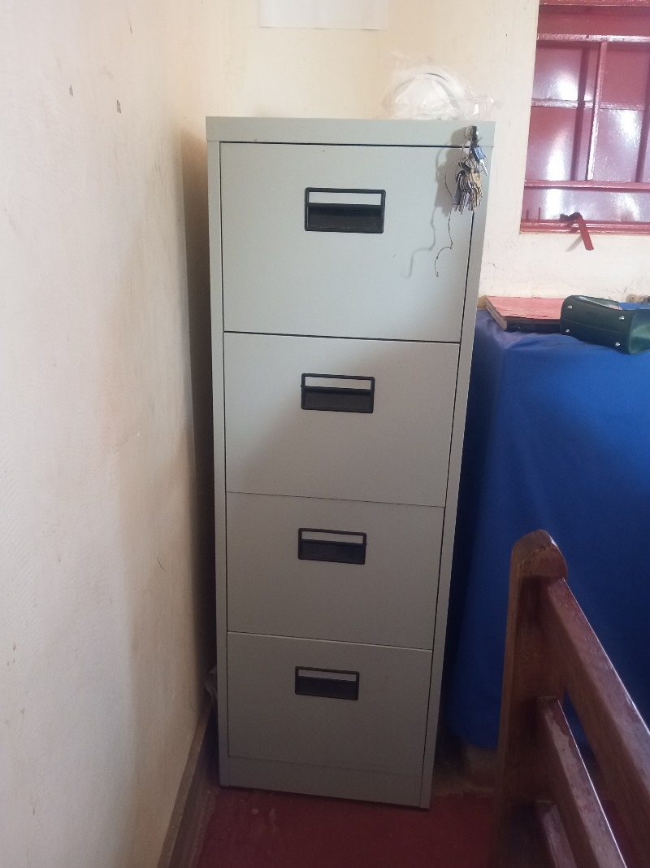

Filing Cabinet

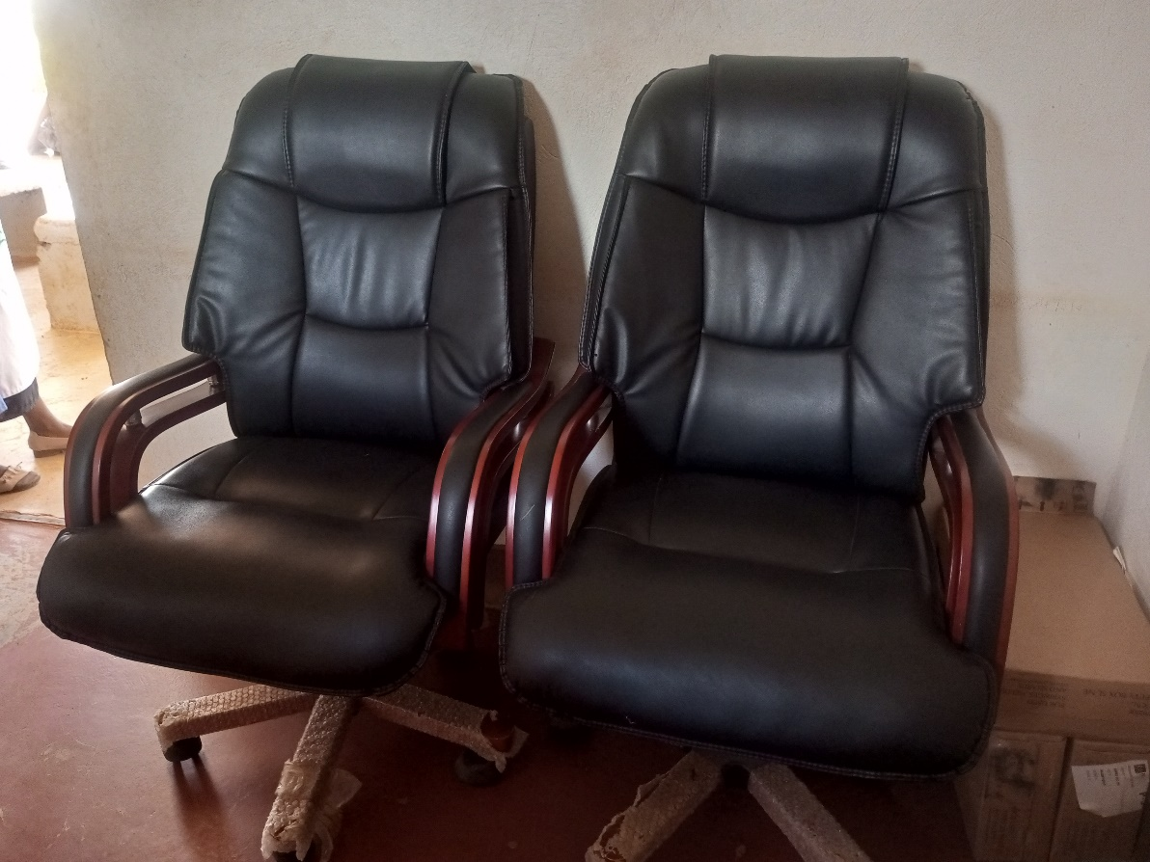

Office Chairs

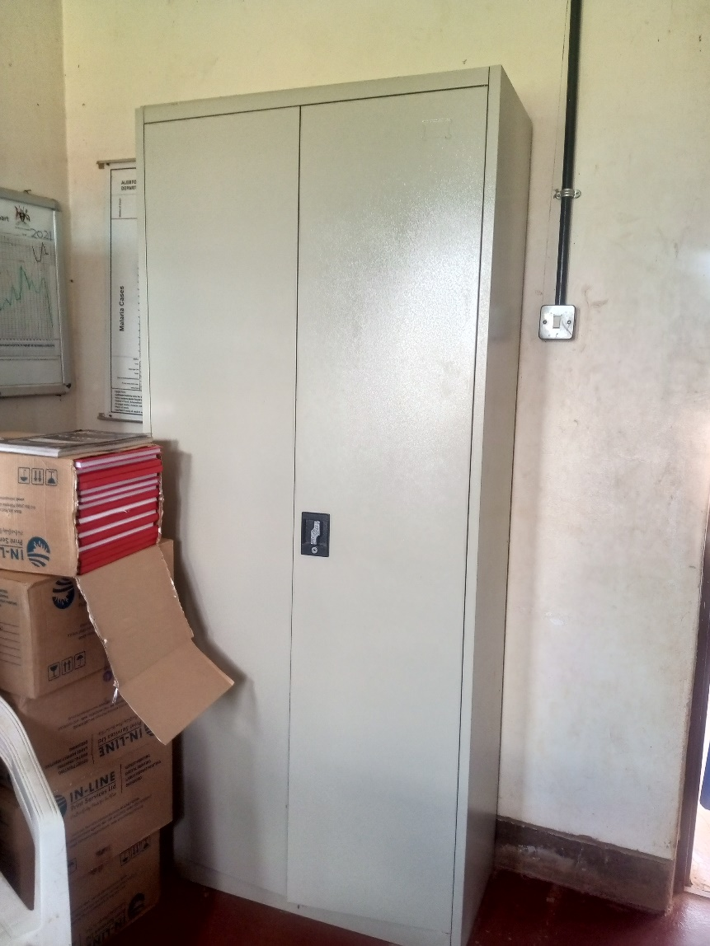

Cupboard Steel Lockable

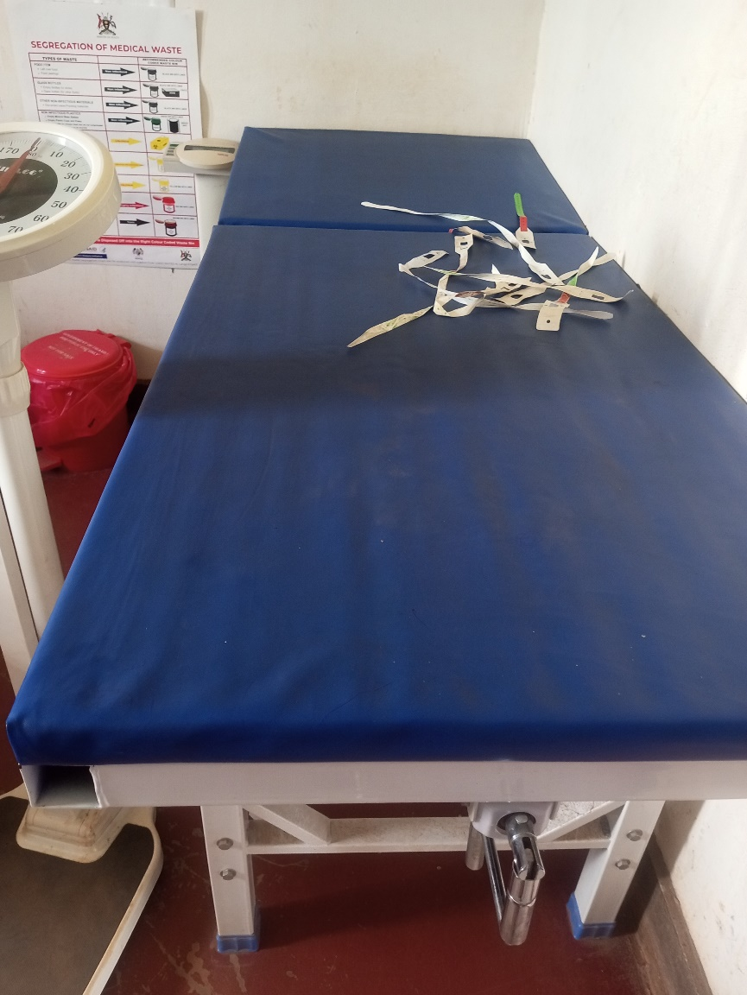

Examination Couch

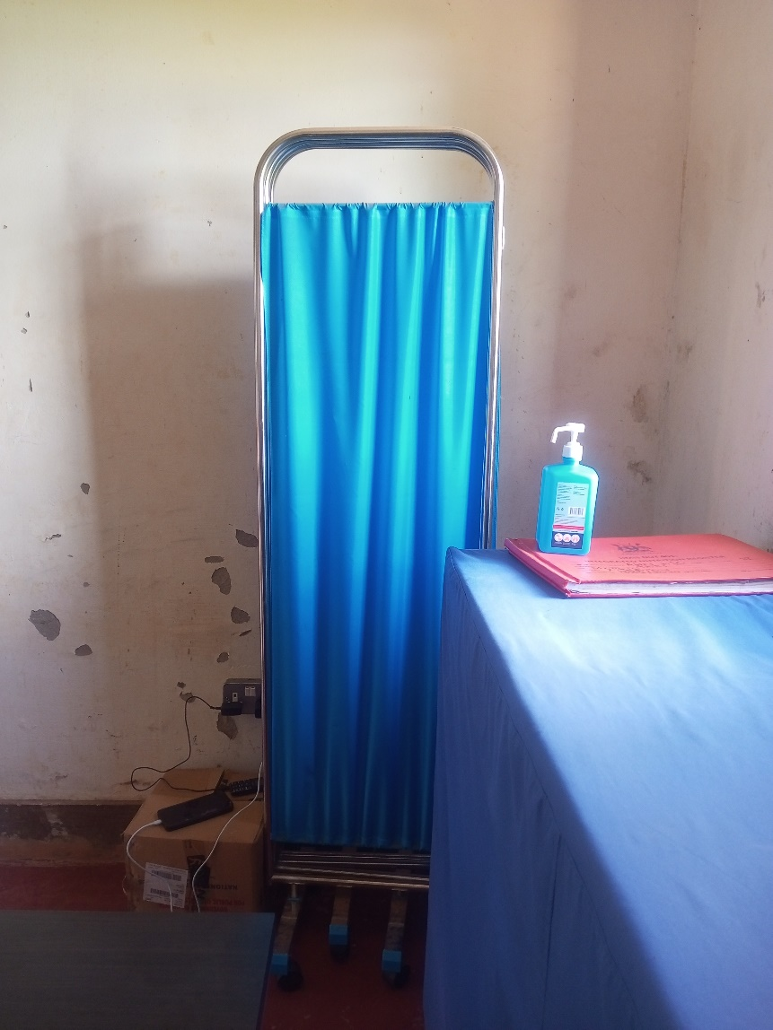

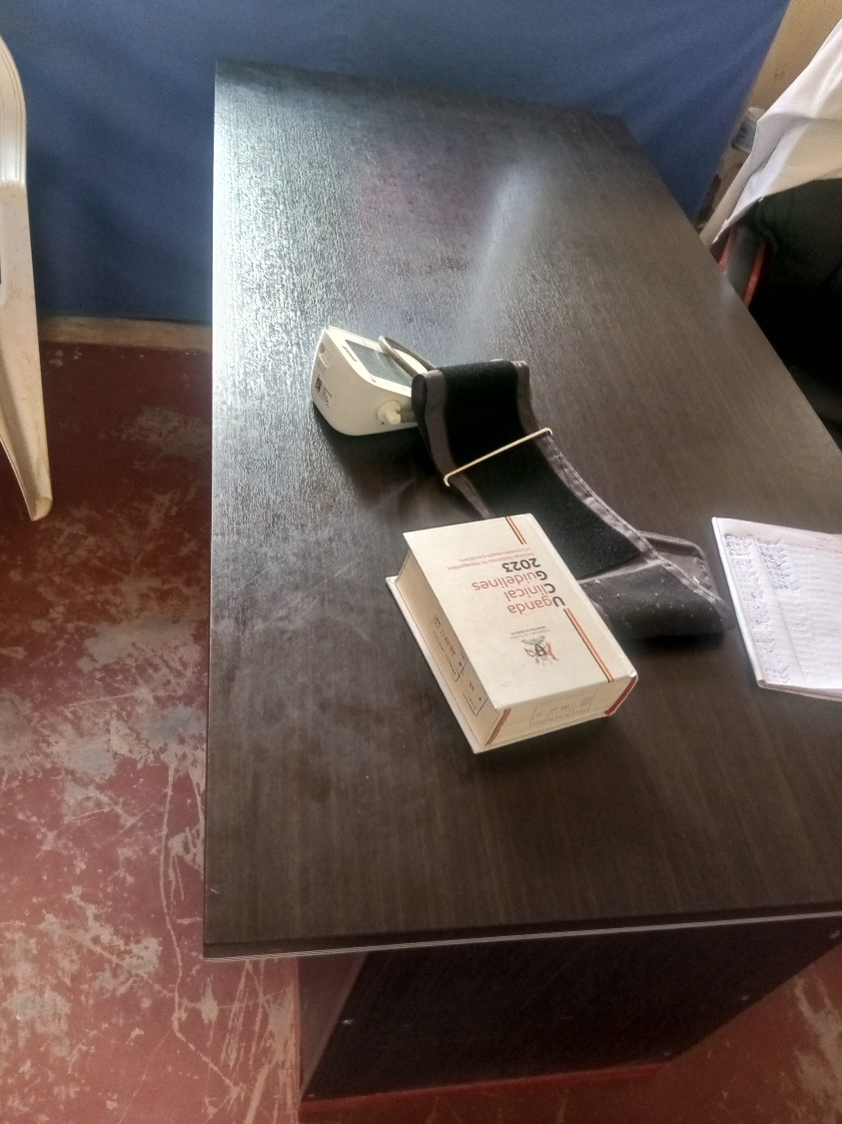

B.P Machine

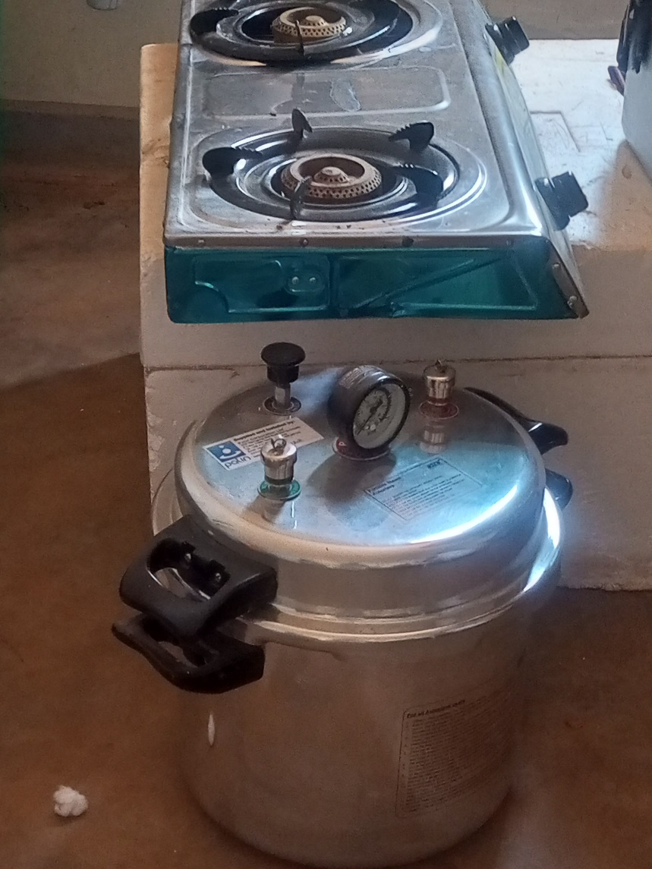

Autoclave and Gas Stove

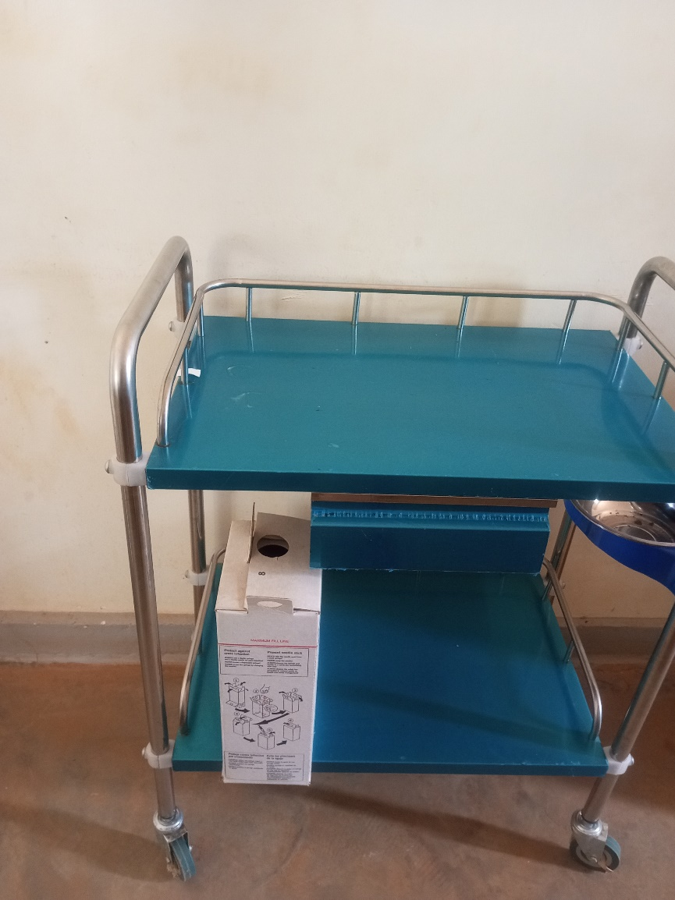

Instrument Trolley

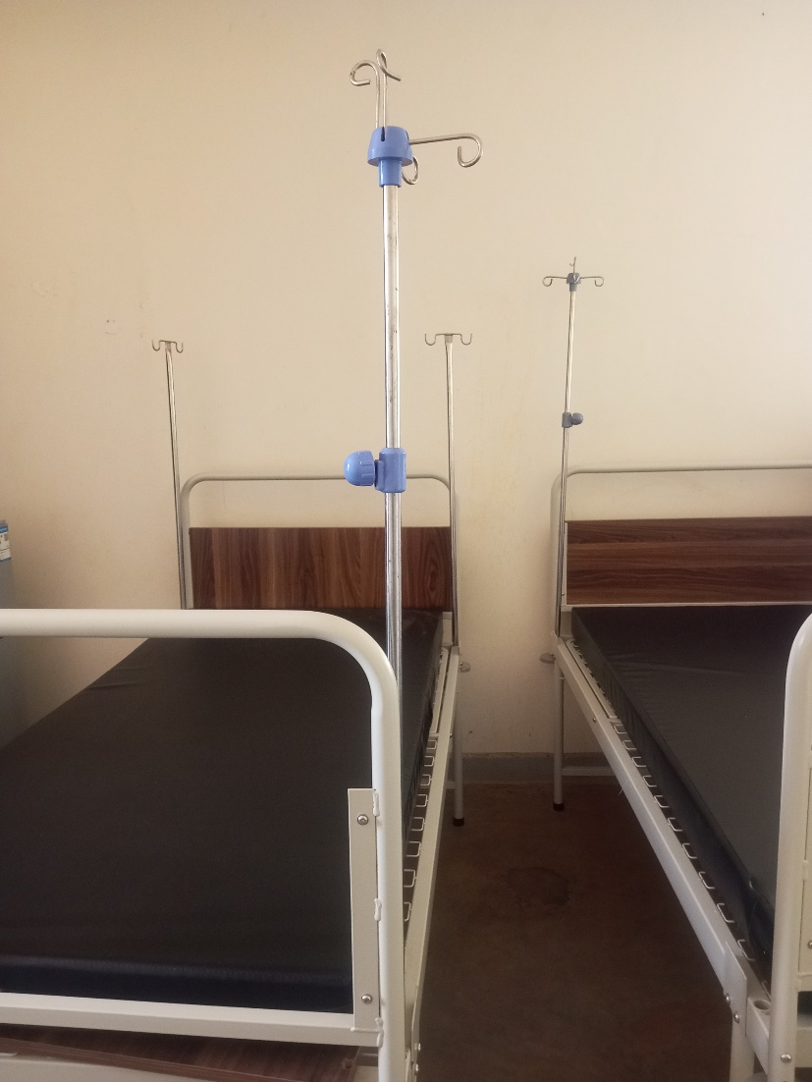

Patient Bed Adult with drip stand

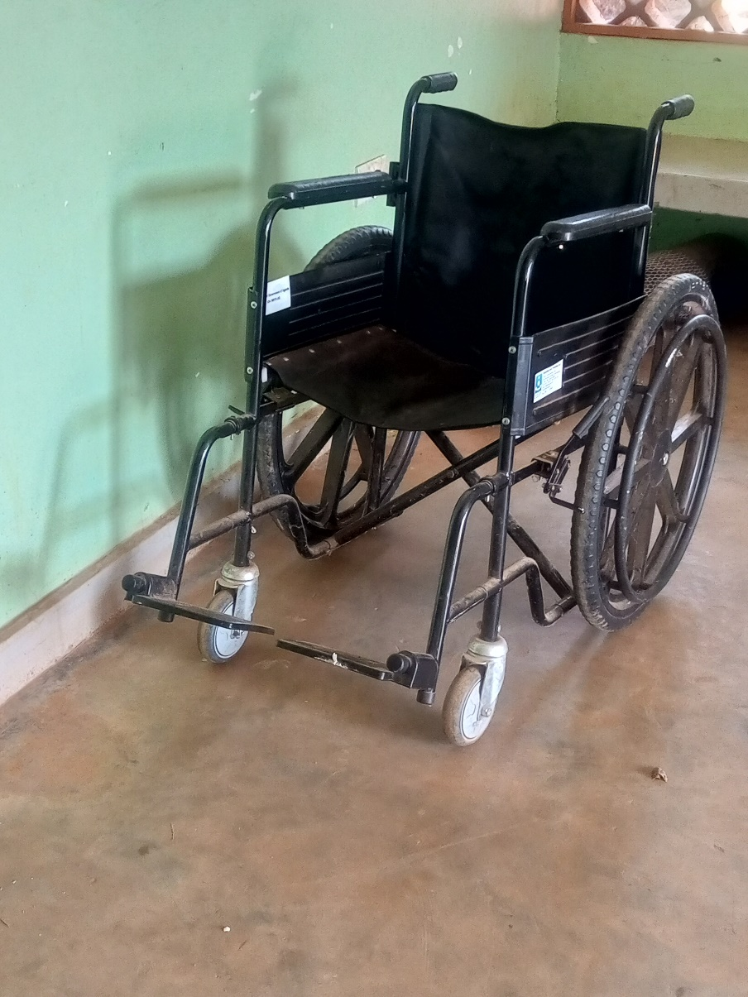

Wheel Chair

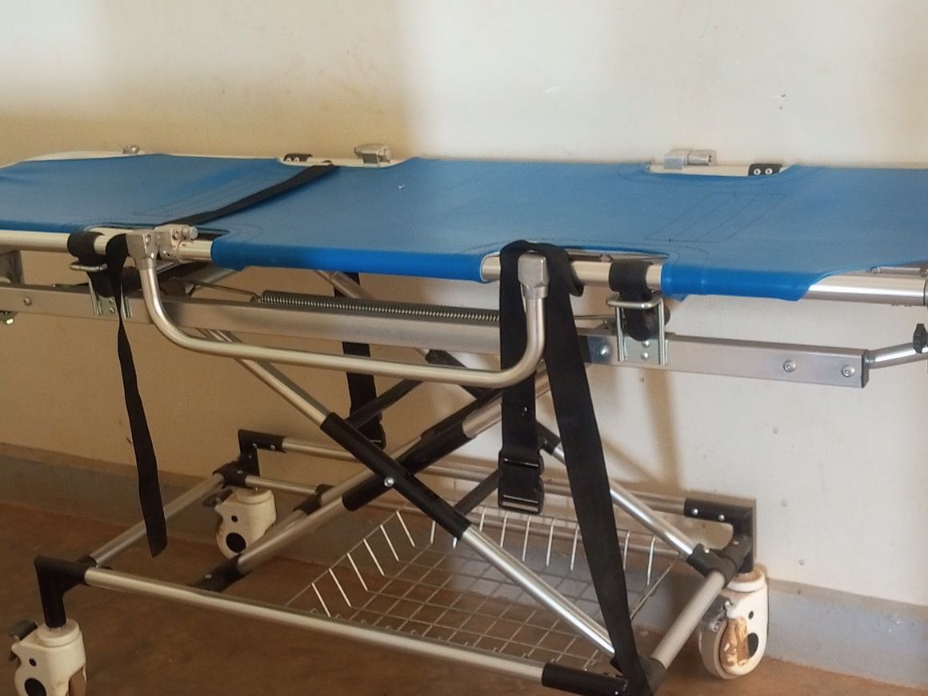

Stretcher

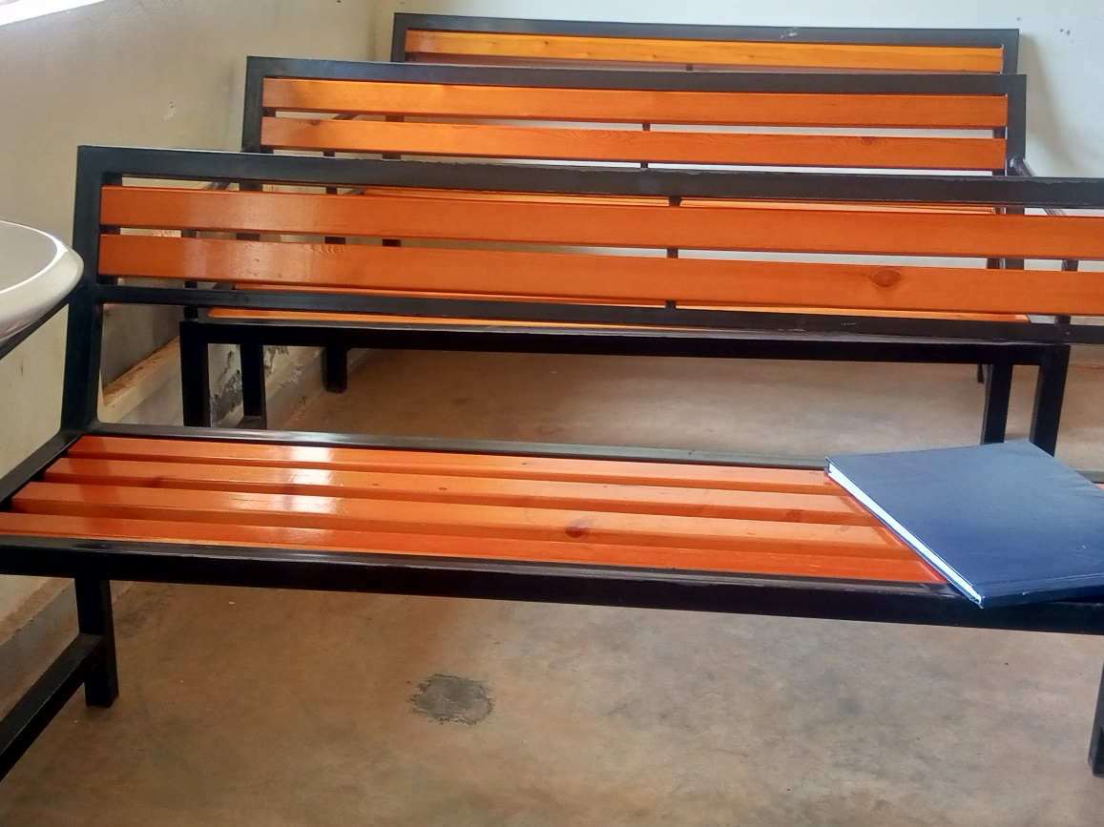

Bench

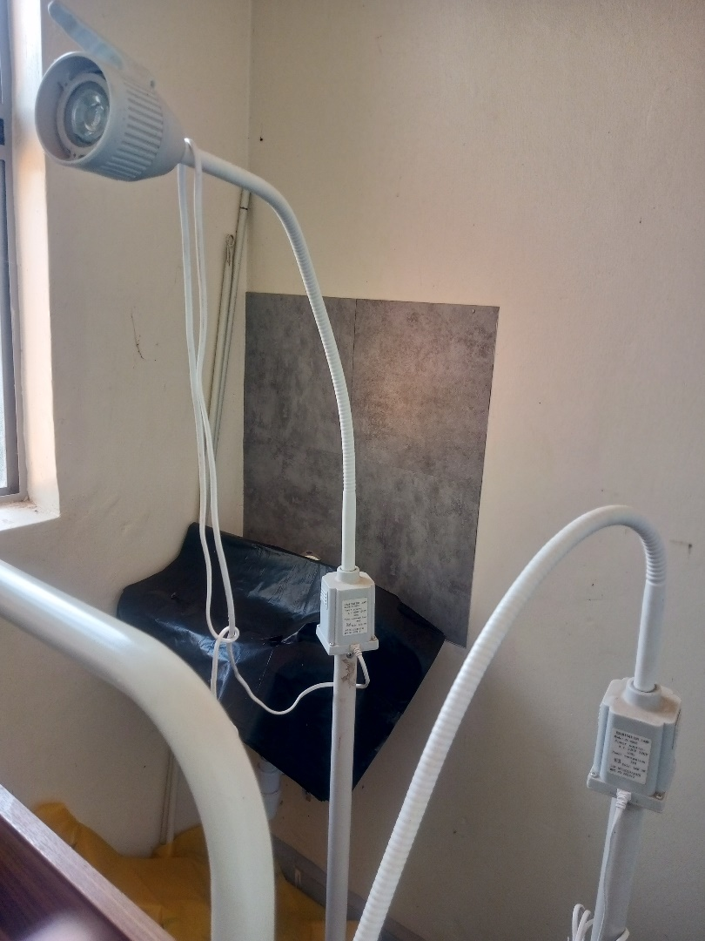

Examination Light LED

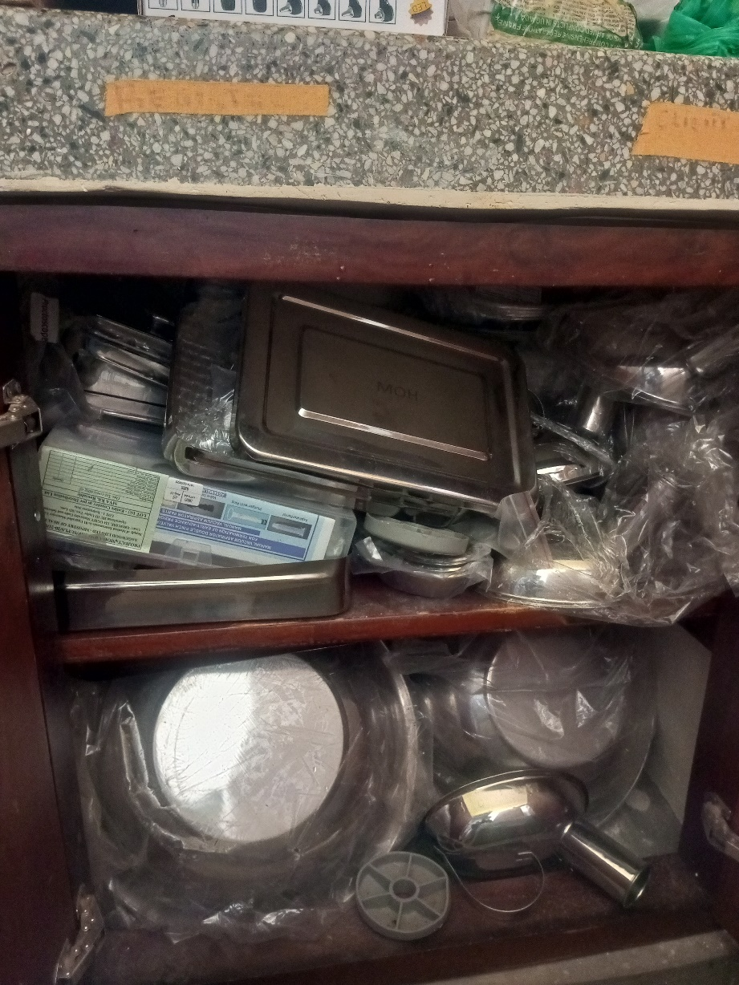

Equipment in the Store

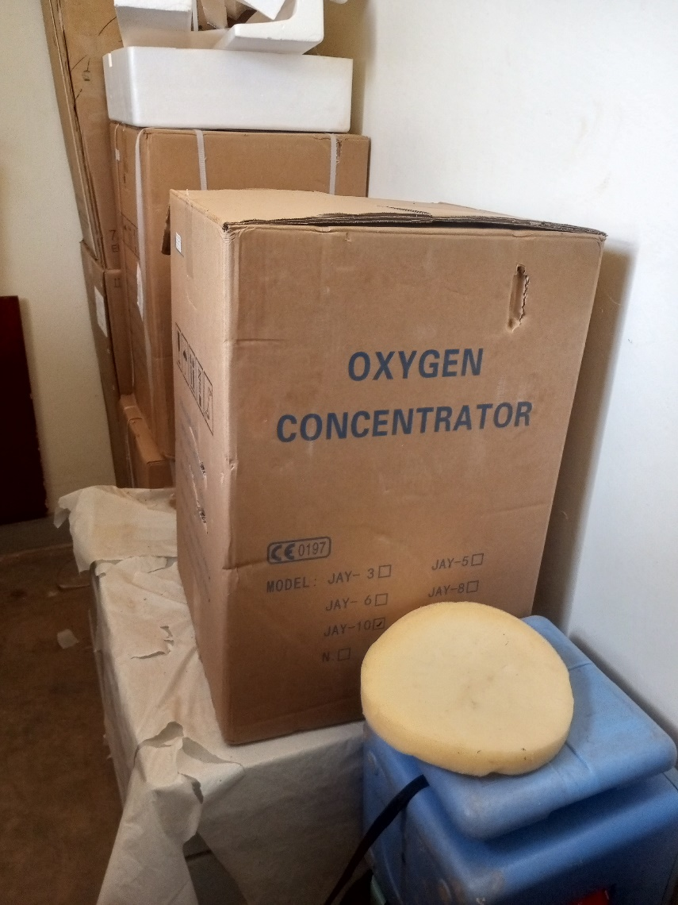

Oxygen Concentrator in the Store

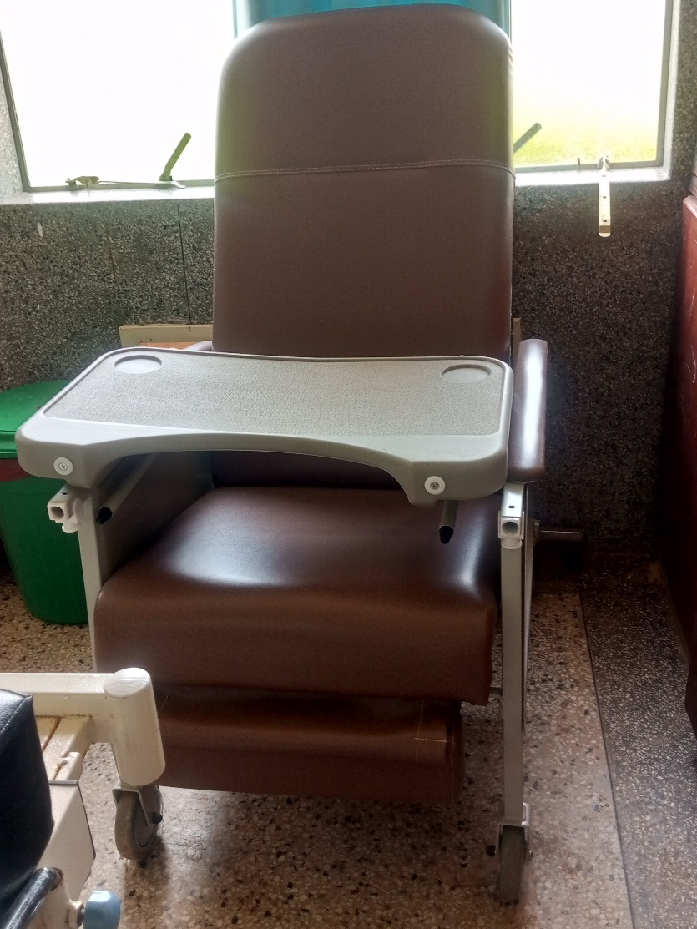

Kangaroo Mother Care Chair

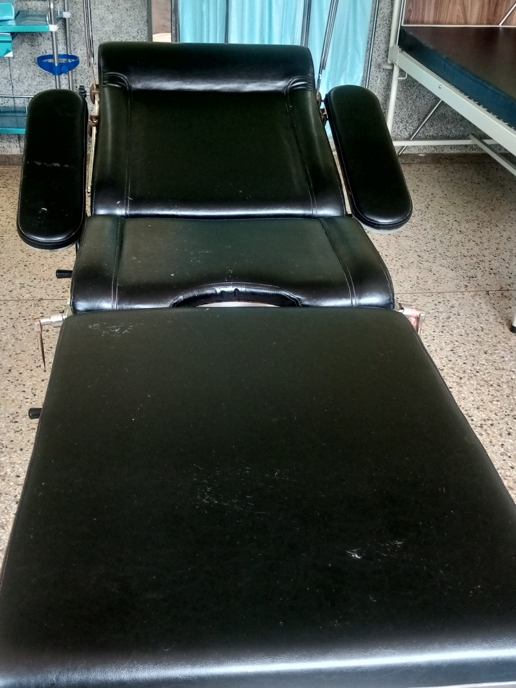

Delivery Bed

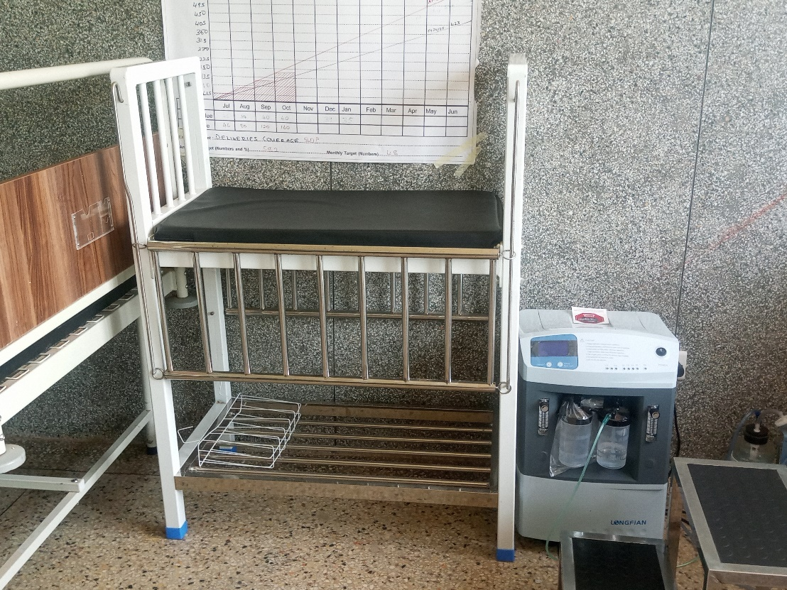

Oxygen Concentrator
Dual Floor

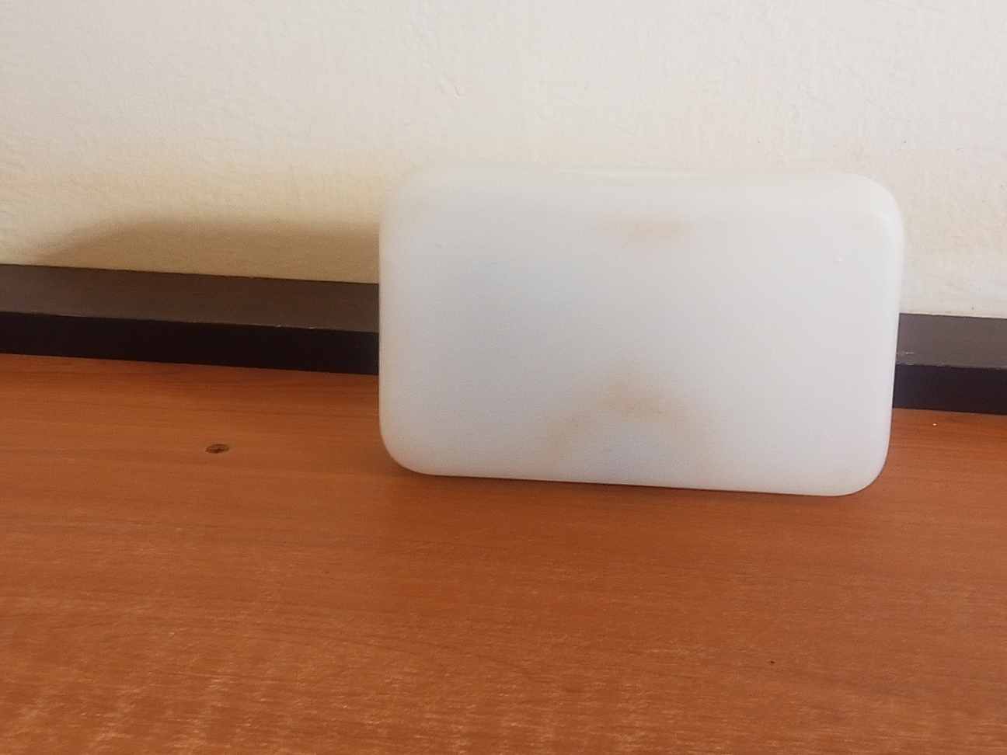

Glucometer

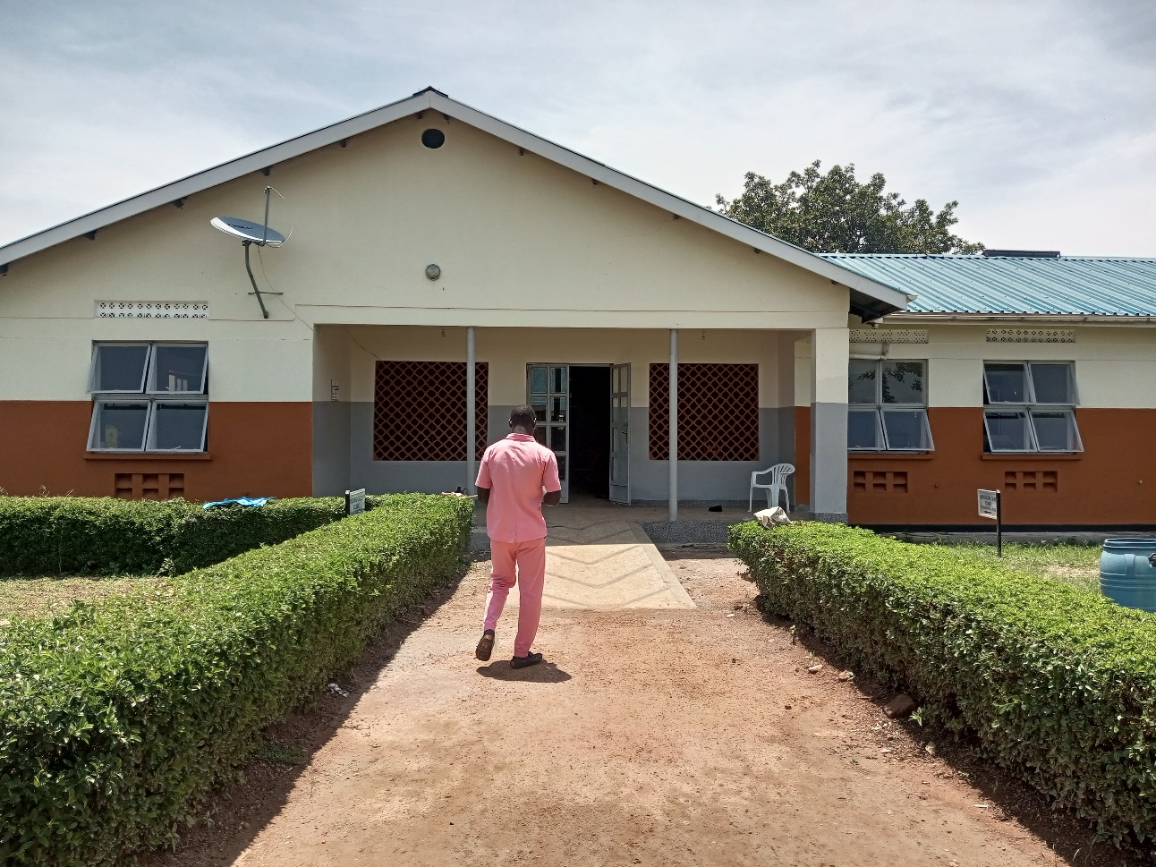

MCH Ward

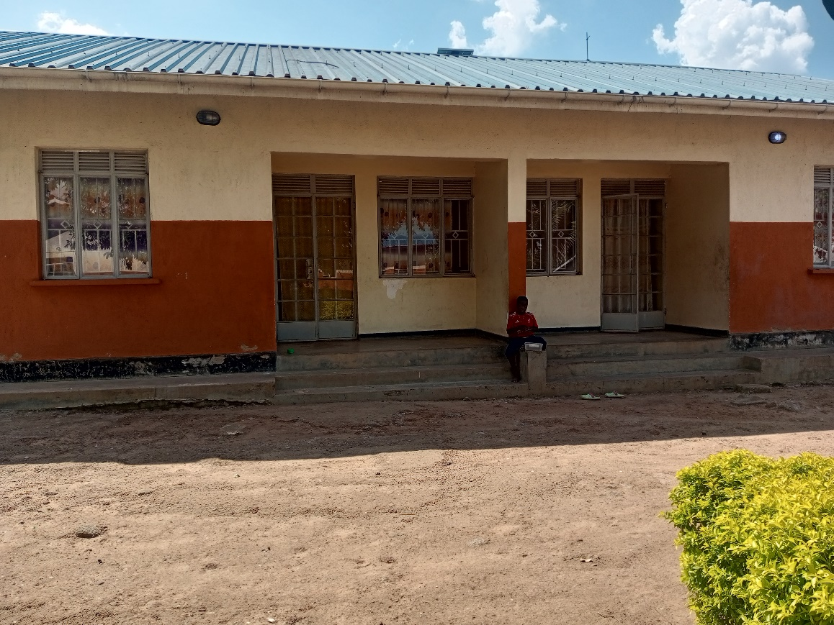

Staff Twin House

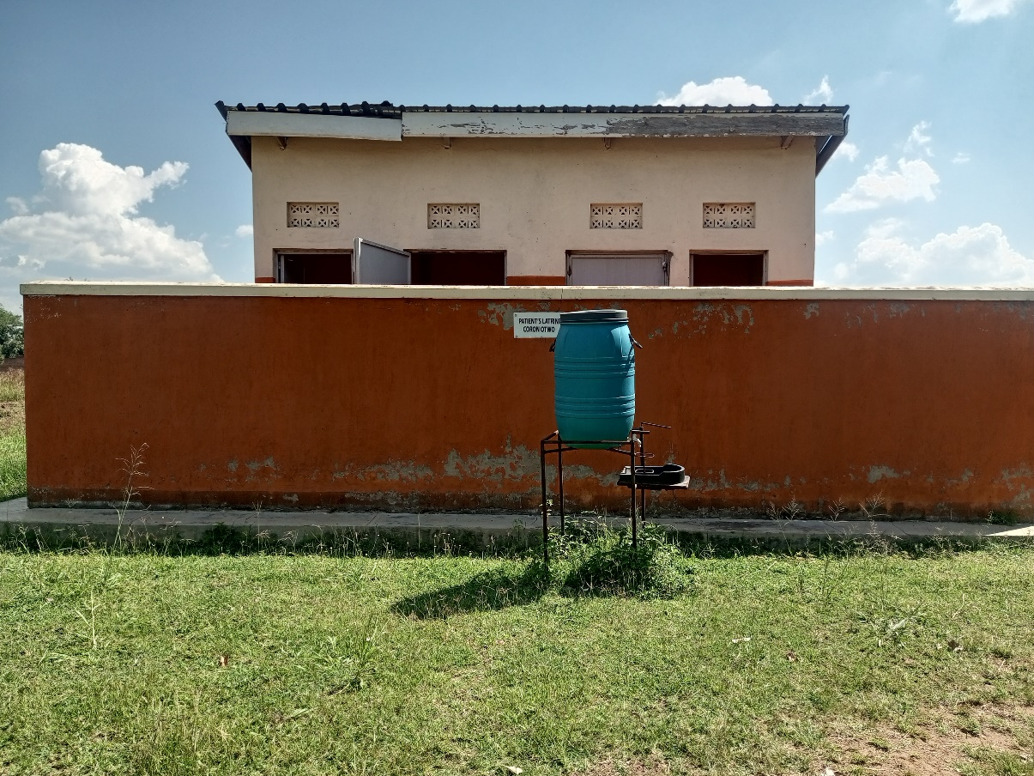

Toilet

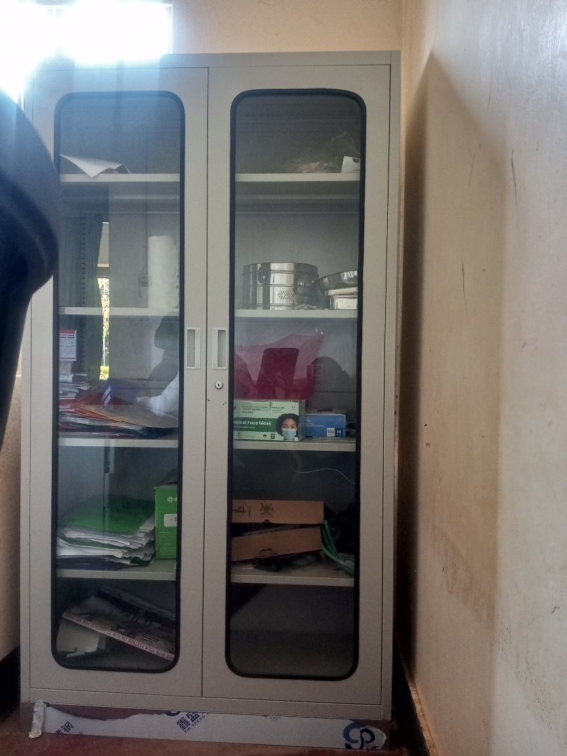

Cupboard Steel Lockable

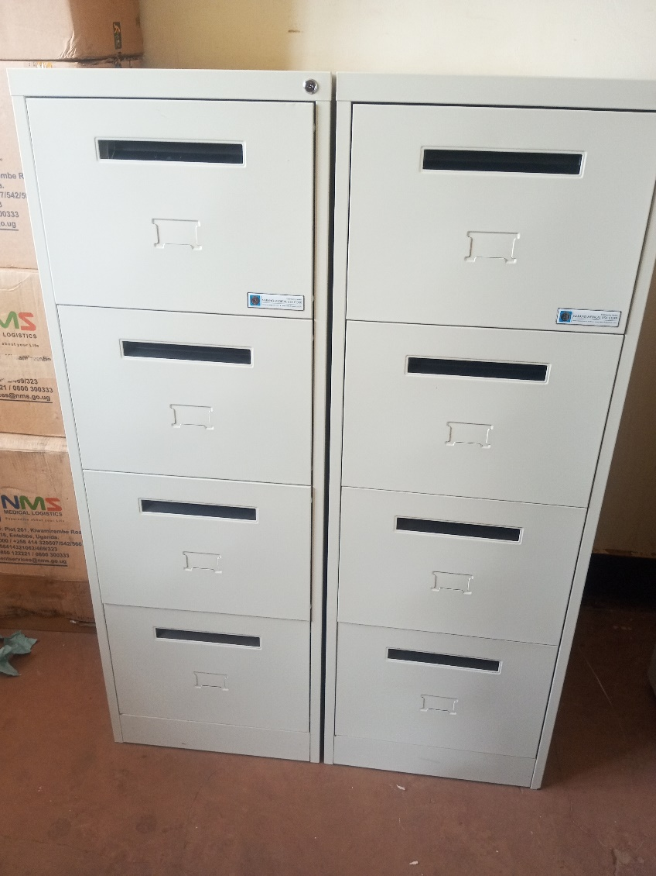

Filing Cabinet

SCHOOL VERIFICATION CHECKLIST

SCHOOL INTERVIEW/DISCUSSION GUIDE

Name of school: ………………………………………………………………………………..

1a | Does the Facility have a record of all assets provided under UgIFT.  (Obtain a record and verify if it has the costs and numbers supplied
1b | If Not ask how many were supplied and when.

2 | How does this facility Maintain (repair/service/replace) the assets provided under Ugift

3 | Does the facility take regular record about functionality/ or breakdown of the assets provided?  Nonfunctional/ working, and reasons for non-functionality.

4 | How has the UgIFT support helped in service delivery in the area, any issues, challenges and any recommendations for better program implementation.

PROCEED TO VERIFICATION AFTER THIS DISCUSSION

SCHOOL FURNITURE
(School Desks, Office chairs, Laboratory stools, Book shelves)

Name of LG………………………………………………………………… Name of SCHOOL………………………………………………………………………………

Equipment/ Item | Department | Asset Number | Item  Description | Life in Months | Tag Number ( engrave no.) | Date Of Pur | Date Placed In Service | Recoverable cost | Cost | Acc Dep Cost | Net Book Value | Ytd Deprn | Equipment status | Remarks

ICT ITEMS TO VERIFY
(Desktop Computer, Server Processor, Network Switch 24 Port, Multipurpose Printer, UPS, Projector, Air Conditioners, Server, CCTV Camera)

Name of LG…………………………………………………………………………… Name of SCHOOL………………………….………………………………………

Equipment/ Item | Department | Asset Number | Item  Description | Life in Months | Tag Number ( engrave no.) | Date Of Pur | Date Placed In Service | Recoverable cost | Cost | Acc Dep Cost | Net Book Value | Ytd Deprn | Equipment status | Remarks

BUILDINGS TO VERIFY
(Non- Residential and Residential, Kitchen, Toilets/Pit latrine Water tanks, Fences etc.)

Name of LG…………………………………………………………………………… Name of SCHOOL………………………….………………………………………

Equipment/ Item | Department | Asset Number | Item  Description | Life in Months | Tag Number ( engrave no.) | Date Of Pur | Date Placed In Service | Recoverable cost | Cost | Acc Dep Cost | Net Book Value | Ytd Deprn | Equipment status | Remarks

